

**IT Department**

**Troublshooting SAS**

Revision Control

|  |  |  |  |
| --- | --- | --- | --- |
| N/A | 9/3/2015 – Created this SOP based off of successful procedure | N/A | J. Lane |
|  |  |  |  |
|  |  |  |  |
|  |  |  |  |
|  |  |  |  |

# SAS Troubleshooting

*Purpose*

To assist in troubleshooting SAS when E-Minor or Web Interface does not work and are given the errors as seen in the following screen shots.

E-Minor:

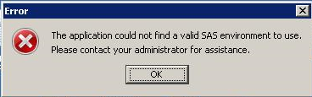

Web interface:

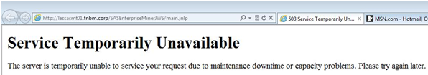

*Procedure*

1. Gain approval from Your department Supervisor as well as Vice President or the Risk Department
2. Create a Ticket in Track-It and create a Change Control Document. You can reference Ticket # 79219 to get the past CCR for this issue.
3. Login to LASSASMT01 using your advisor account
4. Click on Start

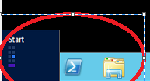

1. Perform Search for Services and start Services



1. Find the following group of services and stop them in the order listed in the screenshot:

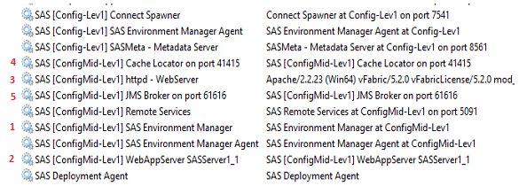

1. Navigate to E:\SAS\ConfigMid\Lev1\Web\activemq\data and delete everything in this folder so that the folder is empty

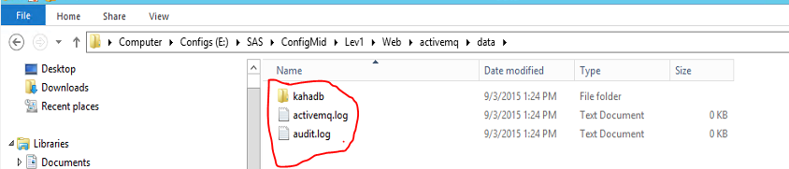

1. Go back to the Services window and restart the services in the order in which they are shown below

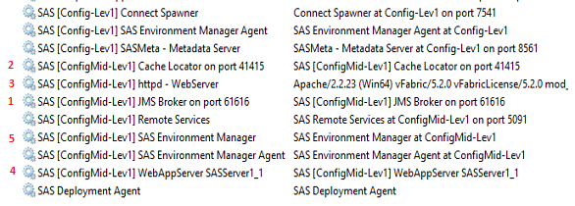

1. After about 10 minutes navigate to the following directory and find and open the server.log file E:\SAS\ConfigMid\Lev1\Web\WebAppServer\SASServer1_1\logs

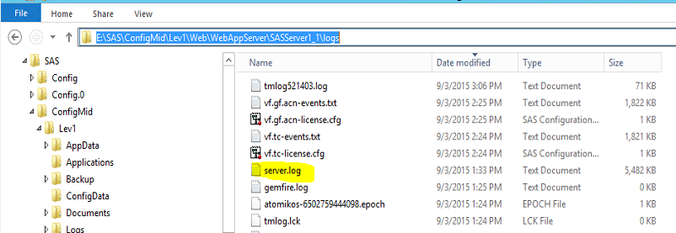

1. Scroll to the bottom of the log file and find the following line

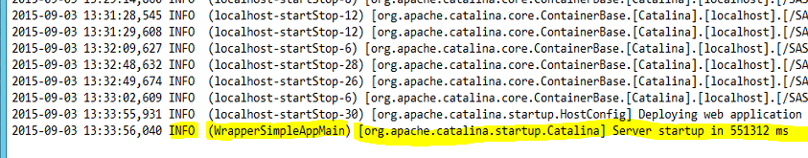

1. If this line is not there, check back every 10 minutes for up to 30 Minutes. If this does not work contact SAS Support at 919-677-8008 using Tech Support Site # 70154948